Name: Class:

Task 1
The following table shows features of traditional currencies and digital currencies. For each feature, tick whether it is part of traditional currencies and/or digital currencies. You may tick more than one box for each feature if appropriate.
 | Traditional currencies | Digital currencies
May use notes
It may be used to buy and sell products
It may use digital numbers stored on a computer
May use coins
It may be reused multiple times
Has no intrinsic value in itself
It makes use of cryptography to prevent unauthorised transactions
Counterfeit currency cannot be created
A government, central bank, or organisation can decide to make more currency

Task 2
Before completing this task, please be aware that the bitcoin wallet that you generate must not be used for storing bitcoin. This is because a number of security precautions have not been taken.
Go to https://bitaddress.org
Move your mouse to create a bitcoin wallet and then answer the following questions.
1. Why do you need to move your mouse around?

2. Paste your bitcoin address below.
3. Paste your private key below.

4. What is the purpose of the bitcoin address? (This may be more obvious if you click the button to show a ‘paper wallet’.

5. What is the purpose of the private key?

Task 3
Go to:
https://www.blockchain.com/btc/block/000000000019d6689c085ae165831e934ff763ae46a2a6c172b3f1b60a8ce26f
This website allows you to view the contents of blocks on the blockchain.
Block 0 is special. It is the first block on the bitcoin blockchain and is known as the ‘Genesis Block’.
(a) Each block needs to store a timestamp of when it was added to the blockchain.
Using the details of the blockchain explorer, find the timestamp for the very first bitcoin added to the block.

(b) The block’s hash is a unique number that identifies each block. Copy below the hash of the first every bitcoin block on the blockchain.
Hash:

(c) Now look at the transactions that occurred at the following bitcoin address:
https://www.blockchain.com/btc/address/1A1zP1eP5QGefi2DMPTfTL5SLmv7DivfNa
We have no information about who owns the bitcoin address, but we do know every transaction that it has made.
Look at the list of transactions and screenshot and paste one transaction below.
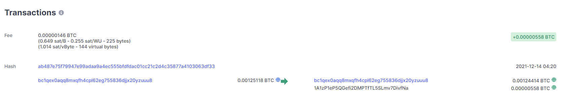
Identify the following details in the transaction by completing the table below:
Transaction details
The transaction hash ID
The timestamp
The sending address, or sending addresses
The receiving address, or receiving addresses
The amount of bitcoin transferred
The fee to validate the block
(d) Find the exchange rate of one bitcoin in pounds sterling (British pounds). You can probably use a web browser with the following query:
“1 BTC in GBP”

(e) In pounds, what was the fee charged for processing and verifying this transaction?

(f) International payments of money typically use the SWIFT payments system. UK banks typically charge a fee of around £20 for this service which takes one day to process.
Compare the use of bitcoin in making this transfer.

